SYSTEM ANALYSIS DOCUMENTATION (SAD)
UMHackathon 2026
umhackathon@um.edu.my
_______________________________________________

Table Of Content
1.Introduction 4
Proposed Solution 4
1.1 Purpose 4
1.2 Background 5
1.3 Target Stackholder 5
2.Introduction 6
2.1 High Level Architecture 6
2.1.1. Overview: 6
2.1.2. LLM as Service Layer 6
Functionality 6
Prompt Construction 6
Context Window 6
Response Handling 6
Token Management 7
2.1.3. Dependency Diagram 7
API Interactions 8
● Frontend → Backend: Upload & request 8
● Backend → AI: Processing request 8
● Backend → Database: Store results 8
2.2 Technological Stack 8
2.2.1. Frontend 8
2.2.2. Backend 8
2.2.3. Database 8
2.2.4. Cloud Deployment 8
2.3 Key Data Flows 9
2.3.1. Frontend 9
2.3.1.1. Data Flow Diagram 9
2.3.2. Normalized Database Schema 9
3.Introduction Functional Requirement & Scope 9
3.1 Minimum Viable Product: 9
3.1.1. Overview 9
3.3 Out of Scope / Future Enhancements 10
4. Monitor, Evaluation, Assumptions & Dependencies 11
4.1 Technical Evaluation: 11
4.1.1. Grayscale Rollout & A/B Testing: 11
4.1.2. Emergency RollBack (ER) & Golden Release: 11
4.1.3. Priority Matrix: 11
4.2 Monitoring: 11
4.2.1. Grayscale Rollout & A/B Testing: 11
4.3 Assumptions: 11
4.4 External Dependencies: 11
5. Project Management & Team Contributions 12
5.1 Project Timeline: 12
5.2 Team Members Role: 12
5.3 Recommendations: 12

1.Introduction
The Credit Transfer System (CTS) is an AI-powered academic evaluation system designed to improve and automate the credit transfer process in higher education institutions.
The current credit transfer process is manual, inconsistent, and highly dependent on individual interpretation. Students are required to submit syllabus documents without clear guidance, leading to incorrect submissions and poor outcomes.
As a result:
- Students may fail to transfer eligible credits
- Study duration increases
- Additional tuition costs are incurred
CTS addresses these issues by integrating AI-driven semantic analysis with rule-based validation to ensure consistent, transparent, and efficient evaluation.

Proposed Solution
CTS is an AI-powered workflow system that:
- Processes uploaded transcript and syllabus documents
- Uses Z-AI GLM for semantic comparison
- Applies rule-based validation (similarity, credit, grade)
- Supports multi-course mapping
- Generates explainable results

1.1 Purpose
This document defines the system architecture and design of CTS.
It serves to:
- Guide system development
- Provide technical reference for stakeholders
- Ensure alignment between system design and requirements

1.2 Background
Traditional credit transfer systems:
- Require manual syllabus comparison
- Lack standard evaluation criteria
- Are time-consuming and inconsistent
Students face difficulties because:
- Syllabus formats vary across institutions
- Course names differ
- No clear evaluation guidance is provided
This leads to:
- Rejected or partial credit transfer
- Increased financial burden
- Inequality in outcomes

1.3 Target Stackholder

Stakeholder | Role | Expectations
Students | Submit applications | Clear eligibility insight
Lecturers | Review decisions | Accurate AI support + justification justification, reduced workload
Admin | Manage system | Efficient workflow
Dev Team | Build system | Scalable architecture
QA Team | Test system | Reliable outputs

2.Introduction

2.1 High Level Architecture

2.1.1. Overview:

2.1.2. LLM as Service Layer
The LLM (Z-AI GLM) is used as a semantic processing service, not the final decision-maker.

Functionality
- Extract structured data from documents
- Compare syllabus content
- Generate similarity score
- Provide explanation

Prompt Construction
Inputs:
- Diploma syllabus
- Degree syllabus
- Course learning outcomes (CLO)
Prompts are structured to ensure consistent evaluation.

Context Window
- Large documents are chunked
- Only relevant content (topics, CLO, description) is used
- Ensures token limit compliance

Response Handling
LLM returns structured JSON:
- Similarity score
- Explanation
- Compared elements
Backend validates before storing results.

Token Management
- Prompt size optimized
- Repeated queries cached
- Reduces cost and latency

2.1.3. Dependency Diagram

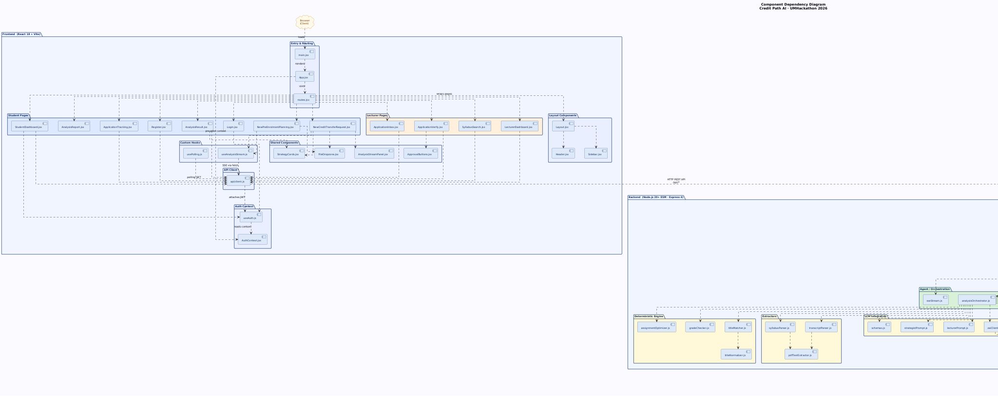
API Interactions

Frontend → Backend: Upload & request

Backend → AI: Processing request

Backend → Database: Store results

2.2 Technological Stack

2.2.1. Frontend
- React / Next.js
- Handles UI and user interaction

2.2.2. Backend
- Node.js (Express)
- Handles business logic and AI integration

2.2.3. Database
SQLite
Stores:
- Syllabus data
- Users
- Evaluations
- Workflow status

2.2.4. Cloud Deployment
- Local deployment (hackathon)
- Optional cloud (AWS)

2.3 Key Data Flows

2.3.1. Frontend
- Accepts user input
- Validates file upload
- Sends structured request to backend

2.3.1.1. Data Flow Diagram
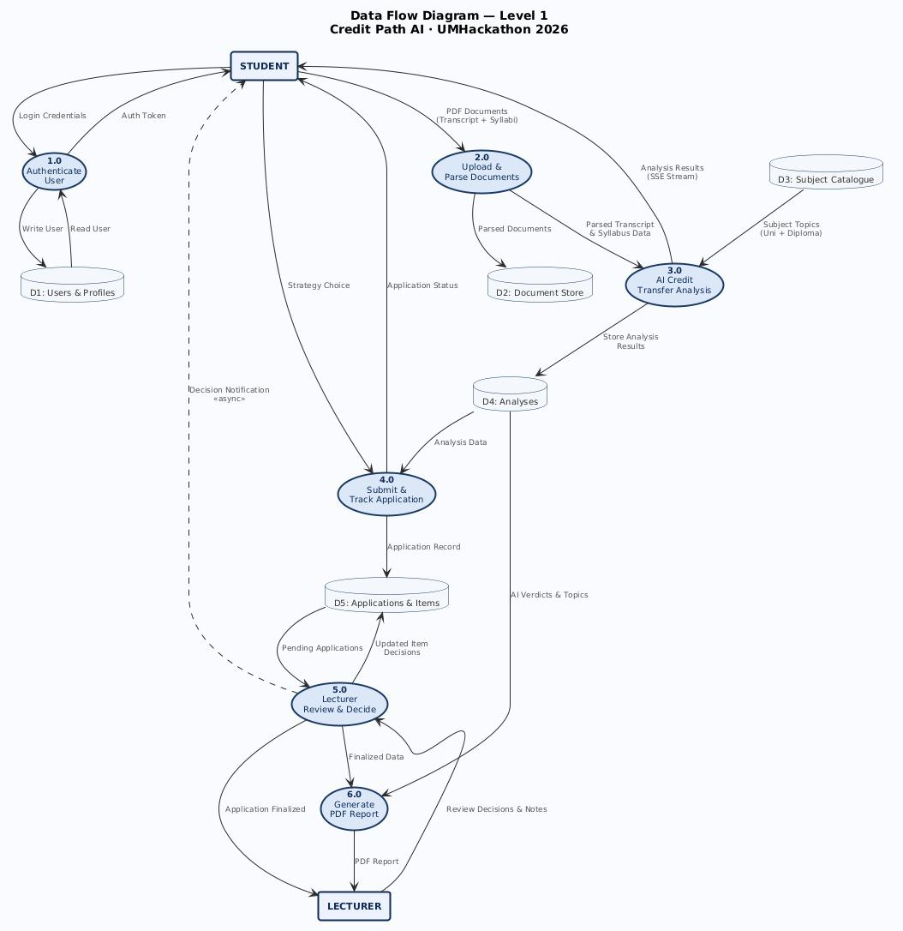

2.3.2. Normalized Database Schema
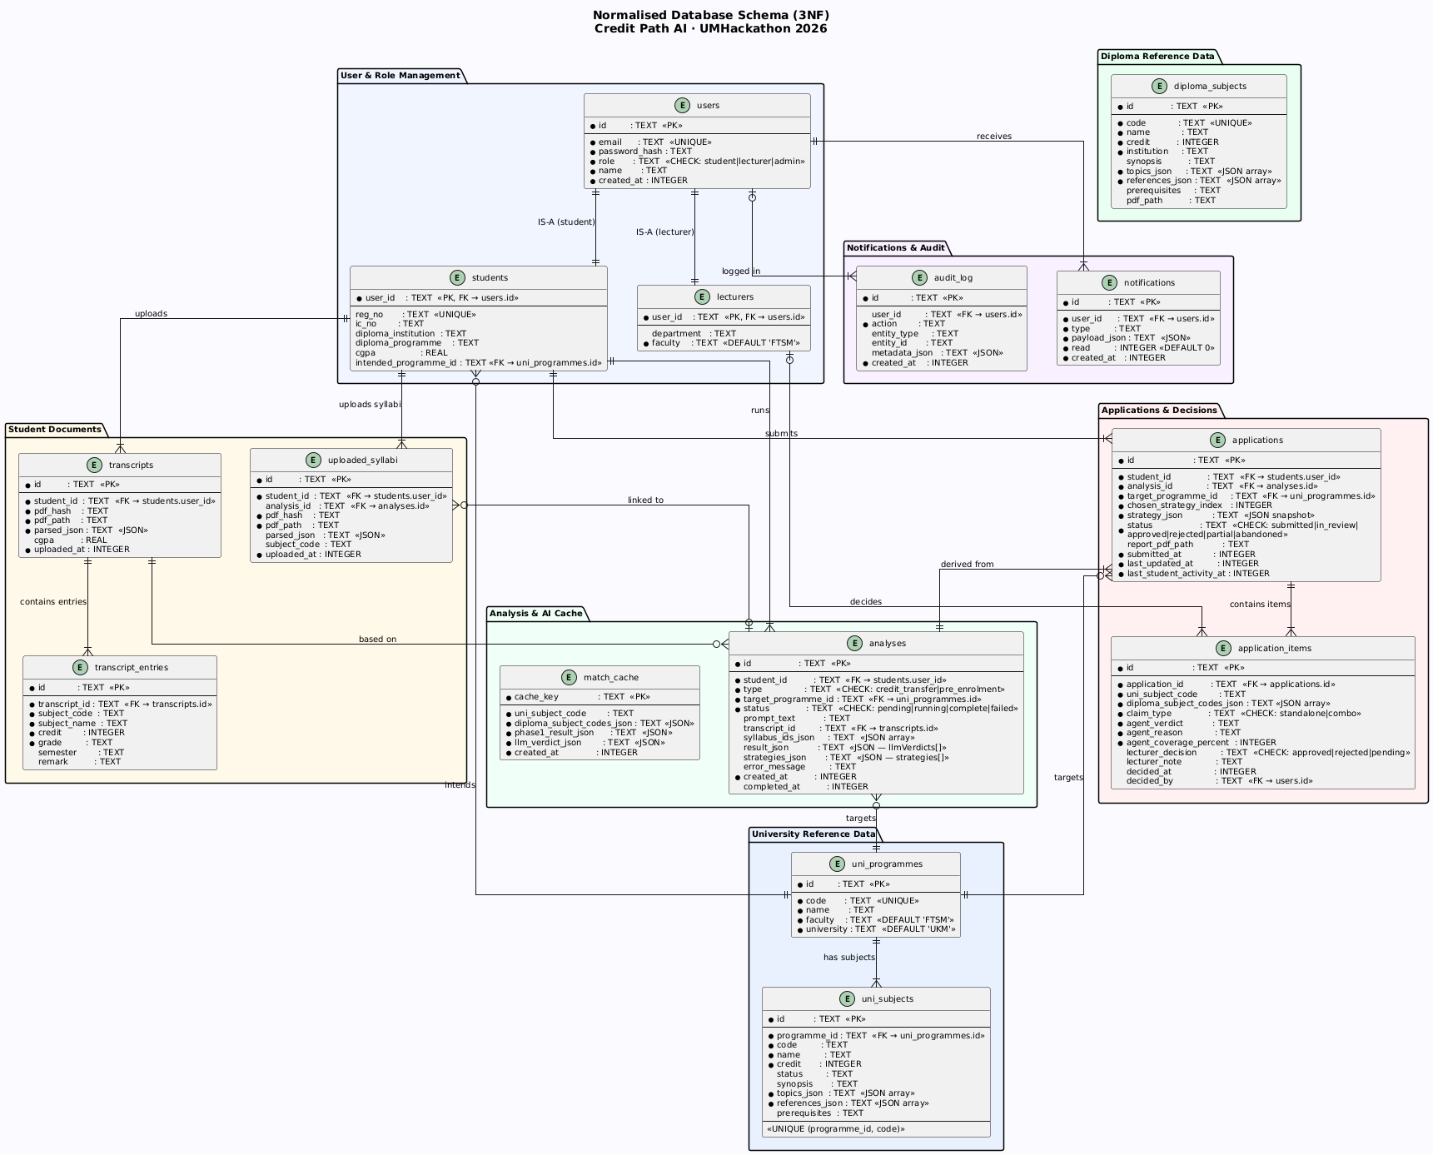

3.Introduction Functional Requirement & Scope

3.1 Minimum Viable Product:

3.1.1. Overview
The MVP focuses on solving the core problem of inefficient credit transfer evaluation.

# | Features | Description
1 | Document Reader | Extracts large number of structured arrays (topic lists, credits, grades) from uploaded transcript and syllabus PDFs.
2 | Live Streaming  Analysis | Provides a real-time visualization of the AI's "thinking process" using SSE as it evaluates ~45 subjects.
3 | Strategic  Optimization | A custom branch-and-bound algorithm to calculate the mathematically optimal subject combinations.
4 | Application handler | A handler that distribute the application to lecturer and track its status

Tool | Purpose | Risk
Z.ai GLM-4.6 | Lecturer reasoning, syllabus  semantic alignment, and  strategy synthesis. | Risk: API Timeout.  Mitigation: Aggressive  SQLite caching of exact evaluations.
pdf-parse & pdfkit | Extracting text from user  uploads and generating the  final formal PDF reports. | Risk: Malformed PDFs breaking regexextractors.  Mitigation: Strict try/catch blocks with logged errors.

3.2 Non-Functional Requirement (NFRs)

Quality Attribute | Implementation Strategy | Description
Scalability | Stateless Backend | Ensures the server can seamlessly scale horizontally to handle high concurrent user traffic during peak university intake periods.
Reliability | Rule Validation | Enforces strict deterministic checks (e.g., the 80% coverage rule) to ensure consistent, predictable outcomes before involving the AI layer.
Performance | Async Processing | Offloads heavy tasks like PDF parsing and external API calls to non-blocking processes, keeping the application responsive.
Latency | < 3 Seconds Target | Guarantees rapid, real-time feedback for the user, especially crucial when streaming the AI's reasoning via Server-Sent Events (SSE).
Cost | Token Optimization | Minimizes LLM API expenses by strictly filtering the context window to only essential topic titles and references, avoiding bloated prompts.

3.3 Out of Scope / Future Enhancements
- AI-guided user customise strategy dashboard
- Multi-university integration
- Precedent memory for AI self-learning
- Version control mechanism on managing university syllabus data
- Integrate payment function

4. Monitor, Evaluation, Assumptions & Dependencies

4.1 Technical Evaluation:

4.1.1. Grayscale Rollout & A/B Testing:
Deploy to small users
Compare prompt strategies

4.1.2. Emergency RollBack (ER) & Golden Release:
Golden Release:
If the Z.ai API experiences extreme rate-limiting, the system gracefully degrades. It bypasses Phase 3 (LLM Edge Case Evaluation) and relies entirely on Phase 1 & 2 (Deterministic string-matching and grade limits). Students still receive an analysis, albeit a strictly conservative one.

4.1.3. Priority Matrix:

Tool | Purpose | Risk
P1 Critical | Evaluation & Dependencies | The Z.ai GLM-4.6 model hallucinates or returns data that fails Zod schema validation.
P1 Critical | Dependencies & Cost | Redundant LLM calls are triggered for the same university and diploma subject combinations.
P2 High | Assumptions | A student uploads an image-based or malformed PDF transcript/syllabus.
P2 High | Monitoring | An unhandled exception causes the 5-phase analysis pipeline to crash mid-flight.
P3 Medium | Monitoring & Evaluation | The LLM analysis takes 30-60 seconds to evaluate the full batch of 45 subjects on a cold cache.

4.2 Monitoring:

4.2.1. Grayscale Rollout & A/B Testing:
- API response time
- Error rate
- Token usage

4.3 Assumptions:
- Students provide valid documents
- Internet access available
- AI service is stable
- University provide access to syllabus data

4.4 External Dependencies:

Tool | Purpose | Risk
Z.ai GLM-4.6 | Lecturer reasoning, syllabus  semantic alignment, and  strategy synthesis. | Risk: API Timeout.  Mitigation: Aggressive  SQLite caching of exact evaluations.
pdf-parse & pdfkit | Extracting text from user  uploads and generating the  final formal PDF reports. | Risk: Malformed PDFs breaking regexextractors.  Mitigation: Strict try/catch blocks with logged errors.

5. Project Management & Team Contributions

5.1 Project Timeline:

Day | Task
1-2 | Planning
3-5 | Backend + AI
6-7 | Frontend
8 | Integration
9 | Testing
10 | Demo

5.2 Team Members Role:

Member | Role
Tay Hoe Guan | Backend + AI
Gunalan | Frontend
Khew Jun Yu | Database
Ng Ming Qian | Testing
Adam | Visuality

5.3 Recommendations:
- Optimize prompts
- Add validation before AI calls

